
Assignment: 4 Subject: Data structures and algorithms
Total Marks: 30

INSTRUCTIONS
Note: Please read instruction before starting assignment and follow all the instructions. Only submission through portal is acceptable. Late submission or submission through email will not be accepted.
- Put all your relevant code files along with word file having all of your code in it in a .zip file and images of output of the program after running in visual studio.
a. Write your Name and registration number in word file.
b. Write your Name and registration number in code files and comment them.
c. Image of handwritten answer is not acceptable.
- Submission is created, submit .zip file on portal before submission deadline.

CLO3
Question 1:
You are provided with a Binary Search Tree (BST) class that includes the following basic operations:
- insert(value): Inserts a new value into the BST.
- search(value): Checks if a value exists in the BST.
- delete(value): Deletes a node with the given value from the BST.
- in_order_traversal(): Returns the in-order traversal of the BST.
Using this provided BST class, implement the following additional functions:
- kth_smallest(k): Write a function to find the k-th smallest element in the BST.
- range_sum(low, high): Write a function to calculate the sum of all node values within a given range [low, high] (inclusive).
- is_balanced(): Write a function to check if the BST is height-balanced.
- find_closest_value(target): Write a function to find the value in the BST that is closest to the given target.
- is_valid_bst(): Write a function to check if the current structure of the tree satisfies the properties of a BST.
- count_nodes():Write a function to count the total number of nodes in the BST.
- count_leaf_nodes():Write a function to count the number of leaf nodes (nodes with no children) in the BST.
- count_full_nodes():Write a function to count the number of full nodes (nodes with exactly two children).
- find_floor(value):Write a function to find the largest value in the BST that is less than or equal to the given value.
- find_ceiling(value):Write a function to find the smallest value in the BST that is greater than or equal to the given value.
CLO1
Question 2: Find In-order, Pre-order and Post-order traversal of following tree. (code not required solve in word file) and delete the nodes in sequence delete(18), delete(30) and show working for delete.
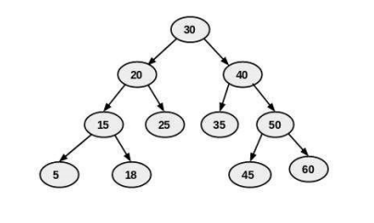
In-order Traversal Result:
5, 15, 18, 20, 25, 30, 35, 40, 45, 50, 60
pre-order Traversal Result:
30, 20, 15, 5, 18, 25, 40, 35, 50, 45, 60
post-order Traversal Result:
5, 18, 15, 25, 20, 35, 45, 60, 50, 40, 30

DELETE(18)
30
/ \
20 40
/ \ / \
15 25 35 50
/ / \
5 45 60
DELETE(30)

35
/ \
20 40
/ \ / \
15 25 35 50
/ / \
5 45 60

After replacing 30 with 35, the duplicate 35 in the right subtree is removed.

35
/ \
20 40
/ \ / \
15 25 35 50
/ / \
5 45 60

